WORLD BEE DAY-20 MAY



WORLD BEE DAY-20 MAY

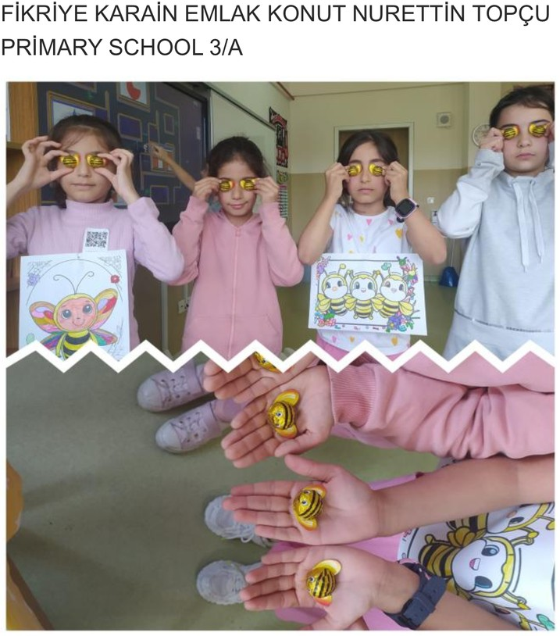

# Bees are yellow and black in color.



WORLD BEE DAY-20 MAY



**They are so tiny, they have 5 eyes. Honey bees have 6 legs. 2 adjacent eyes on the side of their head; Their 3 singular eyes are on top of their heads. In addition, they have 2 pairs of wings, a nectar sac and a stomach.**



WORLD BEE DAY-20 MAY

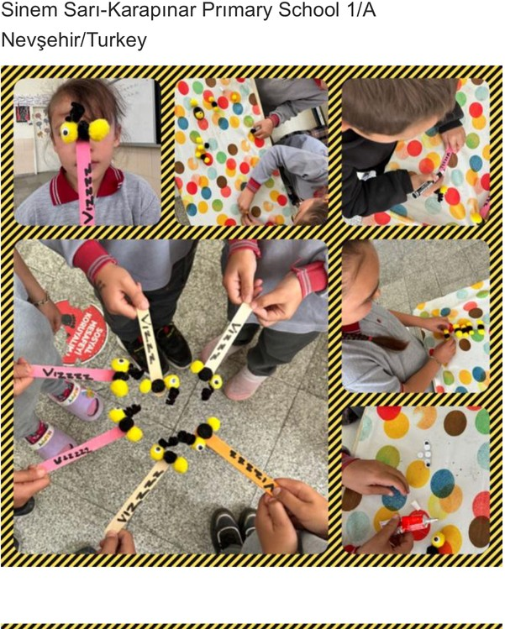

# Only female bees sting

WORLD BEE DAY-20 MAY



# May 20 is celebrated as World Bee Day

WORLD BEE DAY-20 MAY

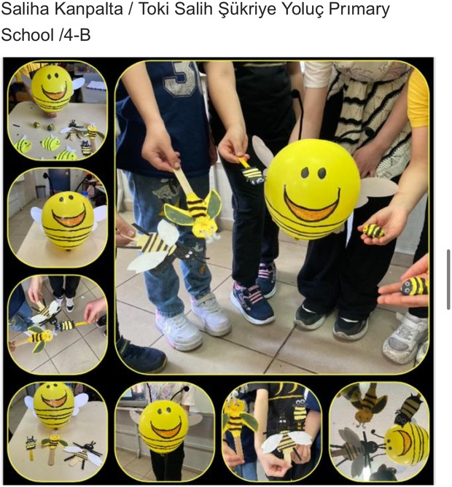

**The hardest working animal:Bees… An average bee produces 1/12th of a teaspoon of honey in its lifetime.**

 



WORLD BEE DAY-20 MAY

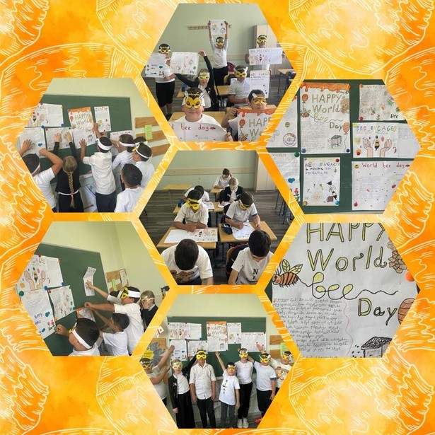

**They also love dancing Honey bees communicate among themselves by dancing**



WORLD BEE DAY-20 MAY

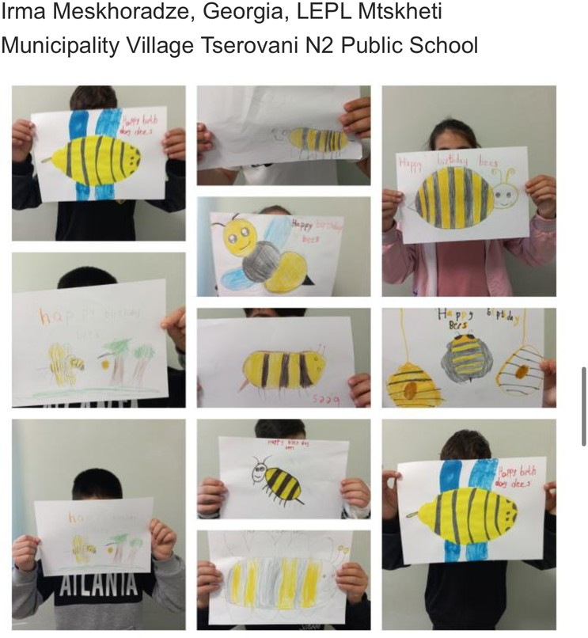

**Honeybees flap their wings faster than you can imagine**



WORLD BEE DAY-20 MAY

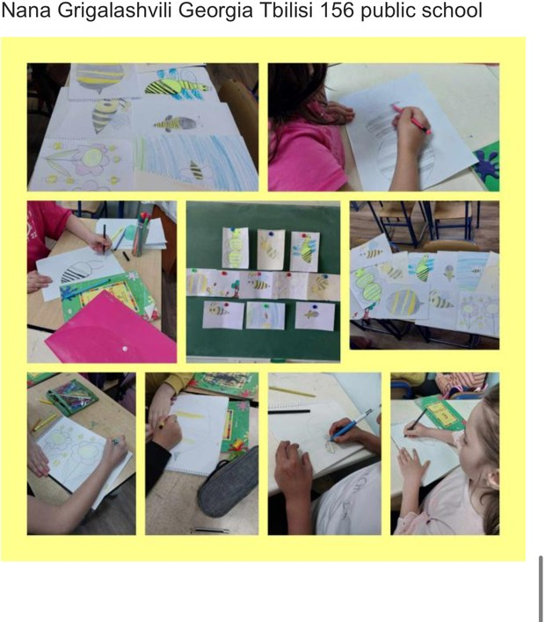

# Bees fly in the air with their wings



WORLD BEE DAY-20 MAY



# Bees live in the hive



WORLD BEE DAY-20 MAY



# Bees collect pollen from flowers.



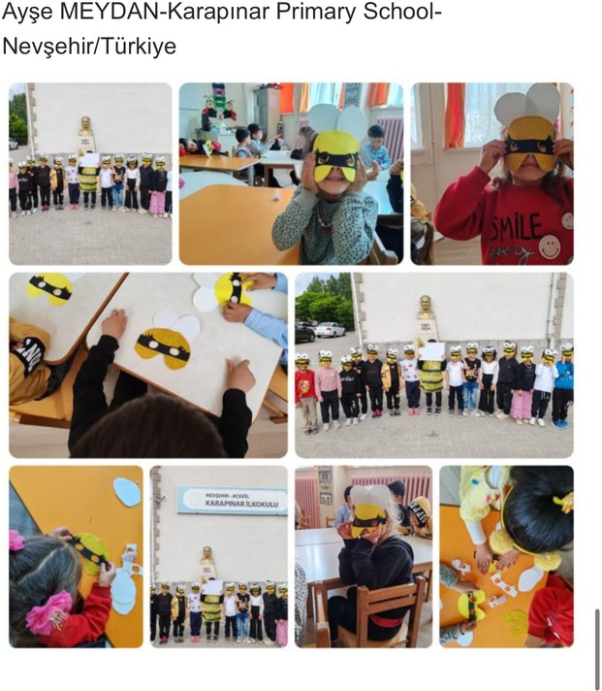WORLD BEE DAY-20 MAY

# Bees make honey from the pollen they collect



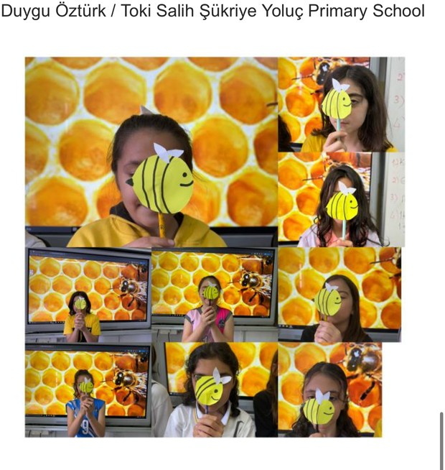WORLD BEE DAY-20 MAY

# honeycombs of bees are hexagonal in shape

WORLD BEE DAY-20 MAY

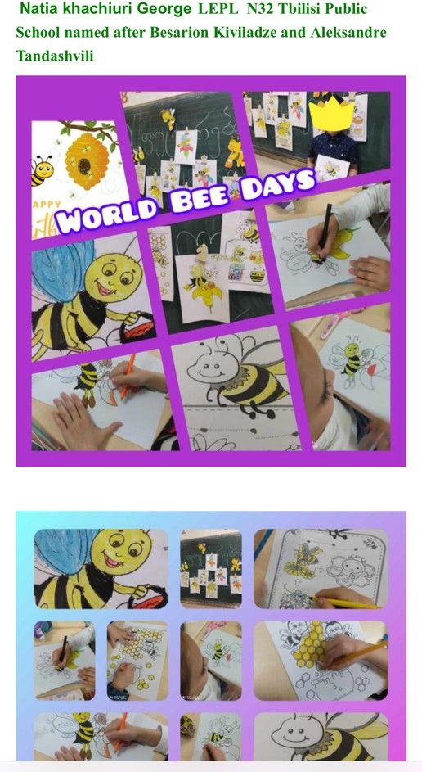

# The queen bee rules the hive