EXCHANGE FILE

surname | Polyzou | 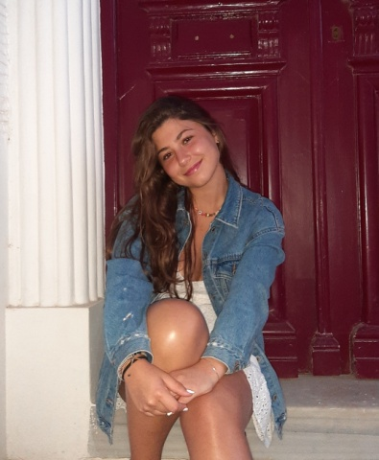
first name | Natalia
gender | Female
date of birth | 31st of July 2006
address | P.E.O. Patron- Athinon
telephone (home) | 2610431621
mobile (student) | 6934754160
mobile (parent) | 6937097001
e-mail (student) | polyzounatalia@gmail.com

FAMILY INFORMATION - Who will be living with the exchange student?
NAME | HOW RELATED TO YOU? | AGE | PROFESSION OR STUDIES  (Be specific!)
Katerina Nikolakopoulou | mother | 51 | Social worker
Dimitris Polyzos | father | 47 | Civil engineer
George Polyzos | brother | 15 | student

OTHER PRACTICAL INFORMATION
 | YES | NO | SPECIFY
Do you have any pets? | * |  | 3 dogs, 6 cats
Do you have any medical conditions?  (e.g. allergies) |  | *
Are you willing to host a member of the opposite sex? | *
Are you willing/able to host more than one exchange partner? |  | *

LAST BUT NOT LEAST
 | EXPLAIN using keywords
Which physical activities do you prefer?  Mention at least 1!  (e.g. sports, walking (your dog), etc.) | Going to the gym
What do you do in your spare time?  Mention at least 3 things! | Listen to music, watching movies, annoying my brother
Which personality traits can we take into account? Mention at least 3!  (This will help to find you a suitable partner.) | Friendly, adaptive, sarcastic
Which habits/routines are there at your house? Mention at least 2!  (e.g. wearing shoes, taking a shower, dinner time, etc.) | Taking a shower, feeding the pets

THIS IS A BRIEF PRESENTATION OF MYSELF
My name is Natalia, I’m 16 years old and I’m in the 11th grade. Later in my school years I would like to study architecture but I may have changed my mind until then. I like math but I hate chemistry. I enjoy spending quality time with my friends as long as they don’t get on my nerves and I love watching movies when it’s dark outside. Also, my house is 50m away from the beach so I tend to spend a lot of time there, even in the winter.

